**TASK 3**

**Project Title: Event Management System using PostgreSQL**

**Project Description:**

To develop the application that allows users to create and manage events, track

attendees, and handle event registrations efficiently.

1. **Database Creation**

**Code-** CREATE DATABASE EventsManagement;

USE EventsManagement;

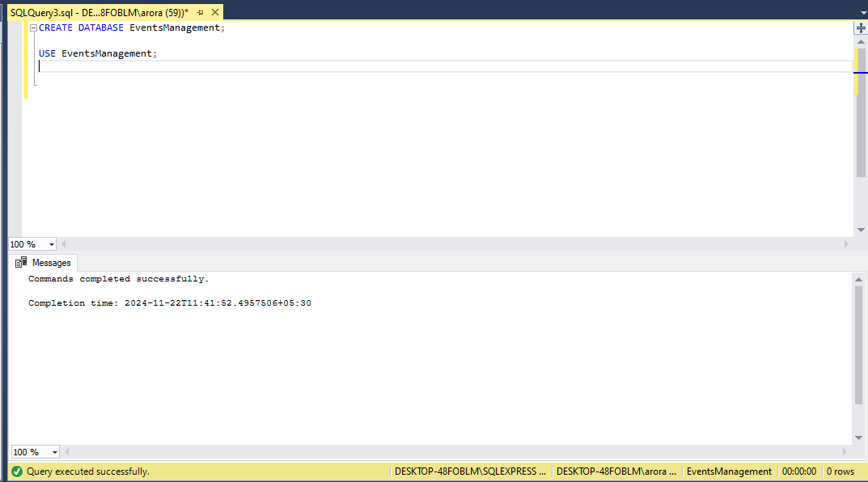

1. **Creation of Tables**

**Code-** CREATE TABLE Events (

Event_Id INT IDENTITY(1,1) PRIMARY KEY,

Event_Name VARCHAR(255) NOT NULL,

Event_Date DATE NOT NULL,

Event_Location VARCHAR(255) NOT NULL,

Event_Description VARCHAR(255));

CREATE TABLE Attendees (

Attendee_Id INT IDENTITY(1,1) PRIMARY KEY,

Attendee_Name VARCHAR(255) NOT NULL,

Attendee_Phone INT NOT NULL,

Attendee_Email VARCHAR(255) UNIQUE NOT NULL,

Attendee_City VARCHAR(255) NOT NULL

);

CREATE TABLE Registrations (

Registration_Id INT IDENTITY(1,1) PRIMARY KEY,

Event_Id INT,

Attendee_Id INT,

Registration_Date DATE NOT NULL,

Registration_Amount DECIMAL(10, 2) NOT NULL,

FOREIGN KEY (Event_Id) REFERENCES Events(Event_Id),

FOREIGN KEY (Attendee_Id) REFERENCES Attendees(Attendee_Id)

);

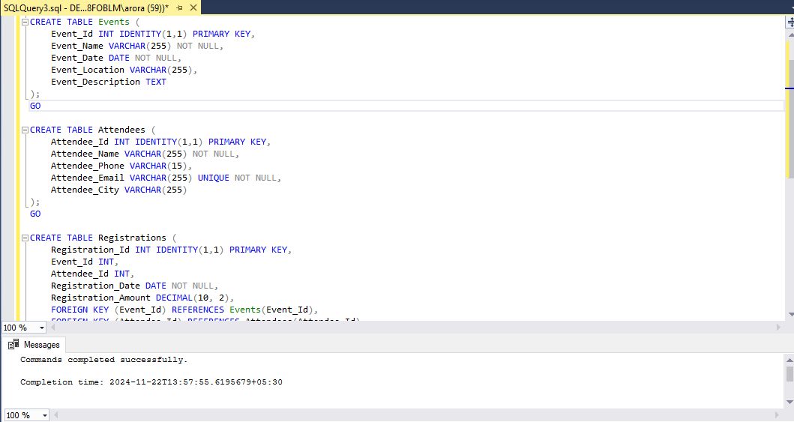

1. **Insertion of Values**

**Code-** INSERT INTO Events (Event_Name, Event_Date, Event_Location, Event_Description)

VALUES

('Tech Conference 2024', '2024-12-15', 'New York Convention Center', 'A conference focused on emerging technologies.'),

('Music Festival 2024', '2024-11-30', 'Central Park, New York', 'A music festival featuring local and international artists.'),

('Health & Wellness Expo', '2024-12-05', 'Los Angeles Convention Center', 'An expo focused on health, fitness, and wellness.');

INSERT INTO Attendees (Attendee_Name, Attendee_Phone, Attendee_Email, Attendee_City)

VALUES

('John Doe', '555-1234', 'johndoe@example.com', 'New York'),

('Alice Smith', '555-5678', 'alicesmith@example.com', 'Los Angeles'),

('Bob Johnson', '555-8765', 'bobjohnson@example.com', 'Chicago'),

('Emma Brown', '555-4321', 'emmabrown@example.com', 'San Francisco');

INSERT INTO Registrations (Event_Id, Attendee_Id, Registration_Date, Registration_Amount)

VALUES

(1, 1, '2024-11-10', 199.99),

(1, 2, '2024-11-12', 199.99),

(2, 3, '2024-11-20', 89.50),

(3, 4, '2024-11-22', 49.99);

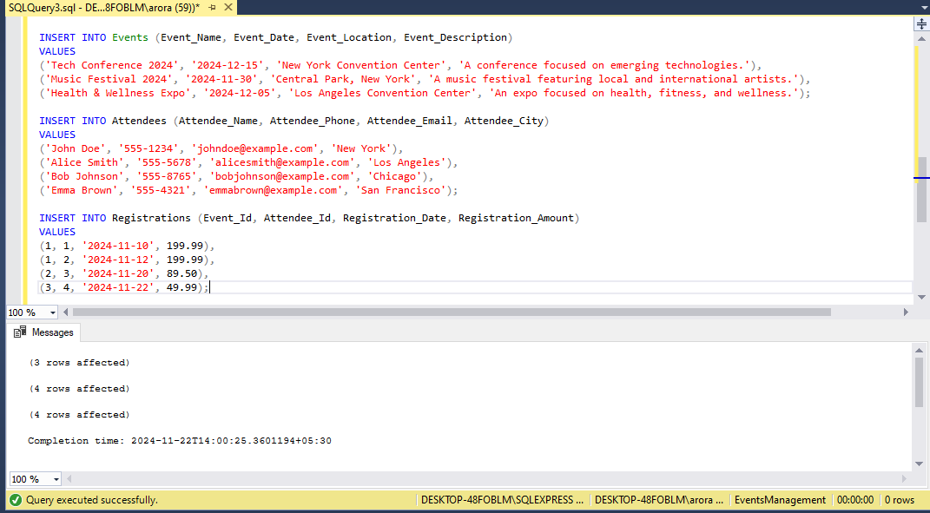

**4.a) Inserting a new event.**

**Code-** INSERT INTO Events (Event_Name, Event_Date, Event_Location, Event_Description)

VALUES

('International Business Summit 2024', '2024-12-05', 'Taj Hotel, Mumbai', 'A global summit for networking, business discussions, and industry growth.');

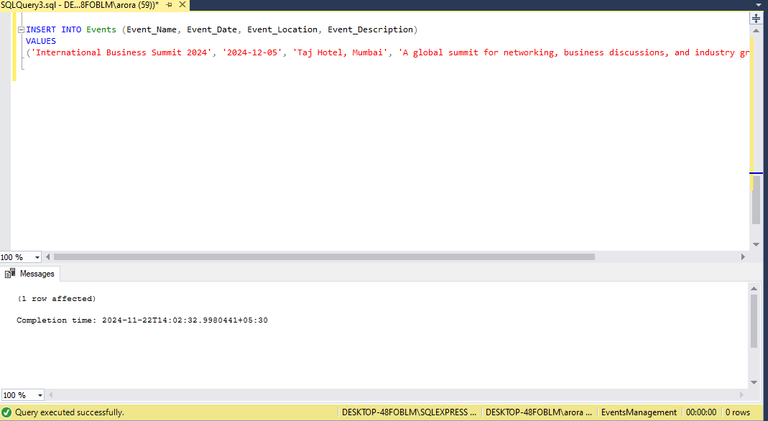

**4.b) Updating an event's information.**

**Code-** UPDATE Events

SET

Event_Location = 'Grand Hyatt, New York',

Event_Description = 'An expanded conference covering more topics in technology, innovation, and trends.'

WHERE Event_Id = 1;

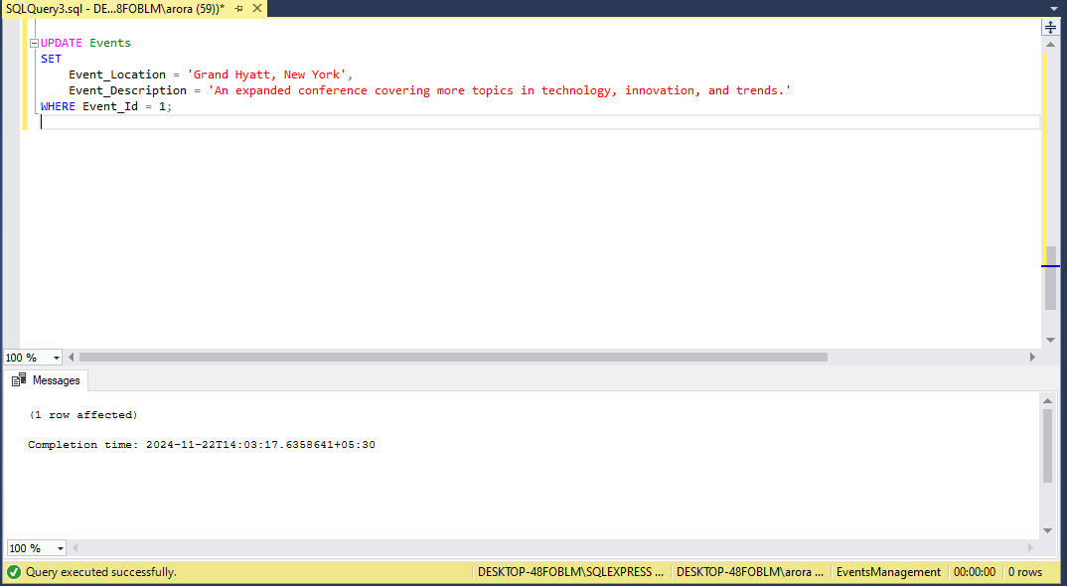

**4.c) Deleting an event.**

**Code-** DELETE FROM Registrations

WHERE Event_Id = 4;

DELETE FROM Events

WHERE Event_Id = 4;

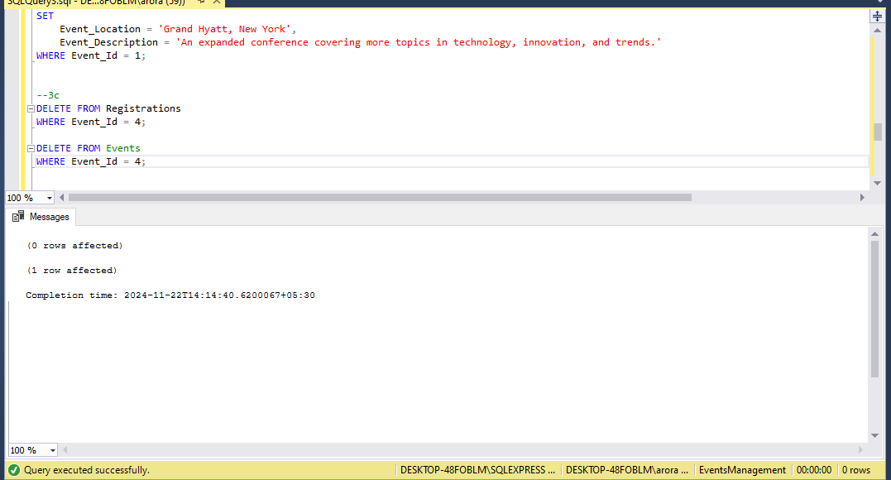

**5.a) Inserting a new attendee.**

**Code-** Inserting a new attendee.

INSERT INTO Attendees (Attendee_Name, Attendee_Phone, Attendee_Email, Attendee_City)

VALUES

('Suresh Kumar', 9988776655, 'suresh.kumar@example.com', 'Chennai');

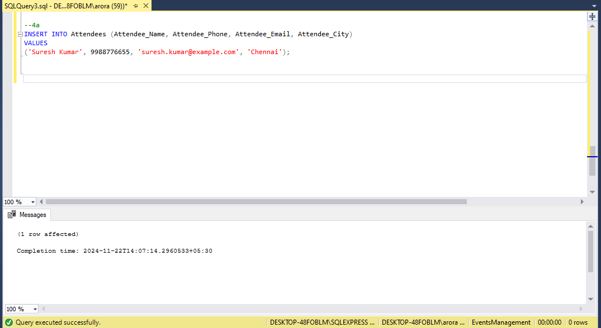

**5.b) Registering an attendee for an event.**

**Code-** INSERT INTO Registrations (Event_Id, Attendee_Id, Registration_Date, Registration_Amount)

VALUES (2, 2, '2024-12-01', 150.00);

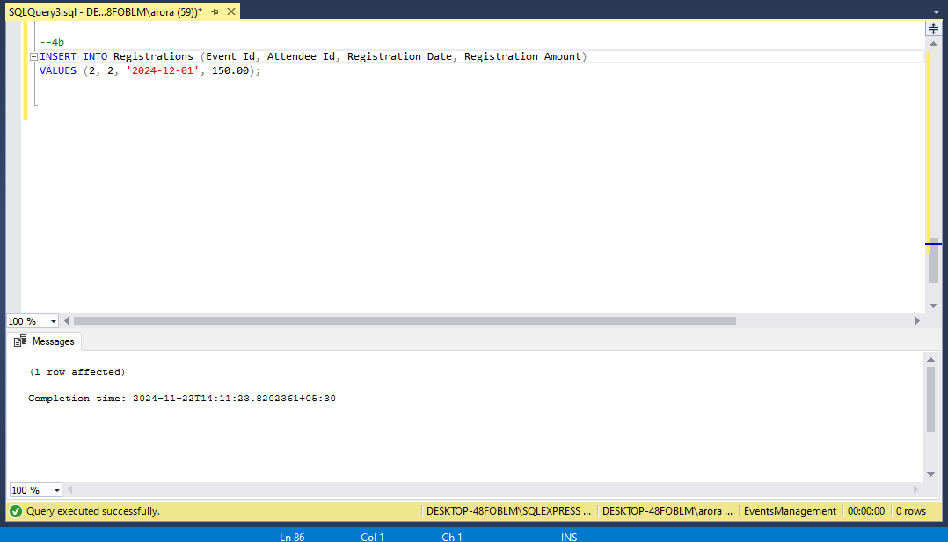

**6. Develop queries to retrieve event information, generate attendee lists, and calculate event attendance statistics.**

**Code-** SELECT Event_Id, Event_Name, Event_Date, Event_Location, Event_Description

FROM Events

ORDER BY Event_Date DESC;

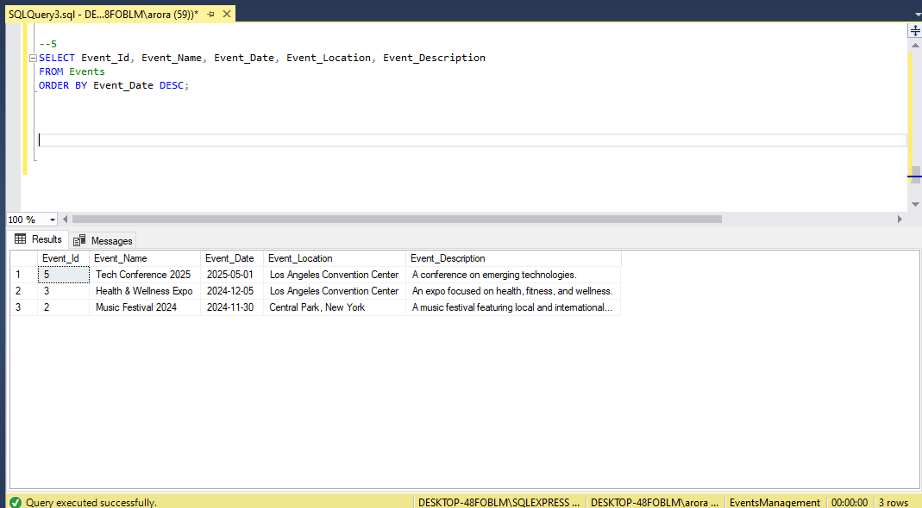

SELECT A.Attendee_Name, A.Attendee_City

FROM Attendees A

JOIN Registrations R ON A.Attendee_Id = R.Attendee_Id

WHERE R.Event_Id = 2

ORDER BY A.Attendee_Name;

SELECT E.Event_Name, COUNT(R.Attendee_Id) AS Total_Attendees

FROM Events E

LEFT JOIN Registrations R ON E.Event_Id = R.Event_Id

GROUP BY E.Event_Name

ORDER BY Total_Attendees DESC;

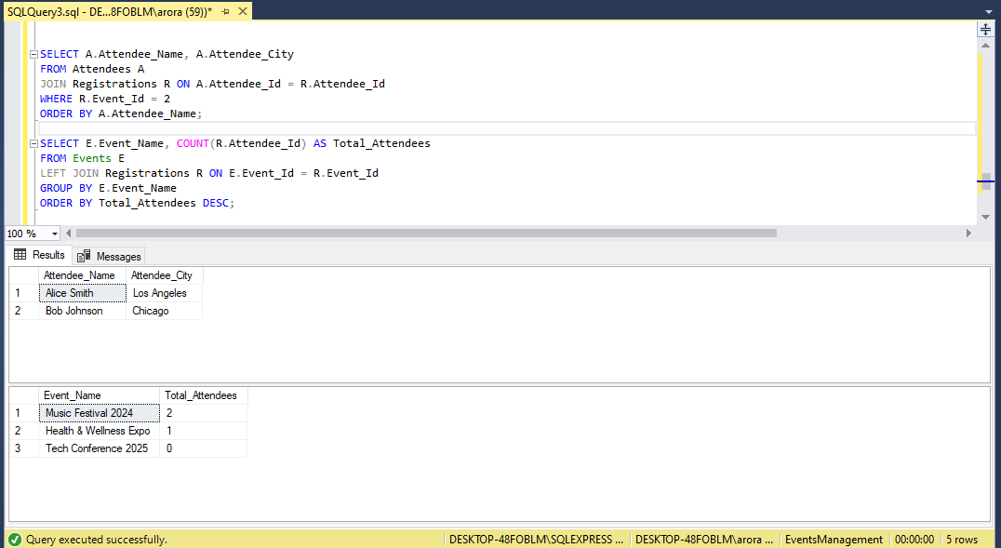

SELECT E.Event_Name, SUM(R.Registration_Amount) AS Total_Revenue

FROM Events E

JOIN Registrations R ON E.Event_Id = R.Event_Id

GROUP BY E.Event_Name

ORDER BY Total_Revenue DESC;

SELECT A.Attendee_Name, E.Event_Name, R.Registration_Amount

FROM Attendees A

JOIN Registrations R ON A.Attendee_Id = R.Attendee_Id

JOIN Events E ON R.Event_Id = E.Event_Id

ORDER BY E.Event_Date DESC, A.Attendee_Name;

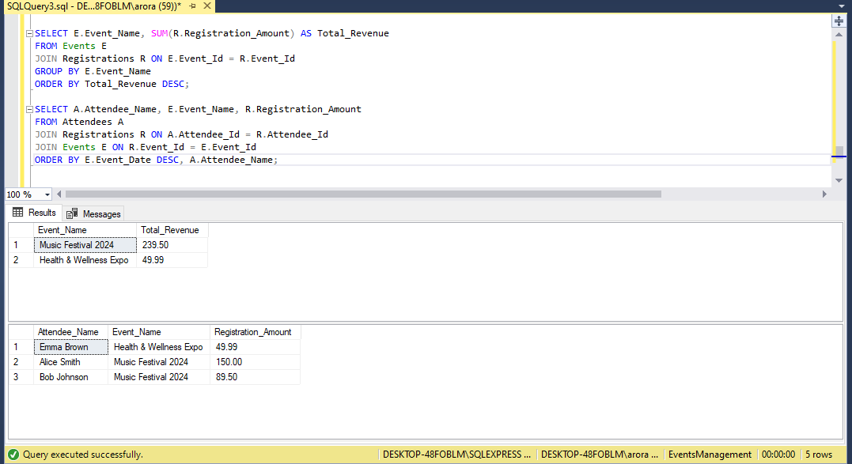

SELECT AVG(Attendees_Count) AS Average_Attendees_Per_Event

FROM (

SELECT COUNT(Attendee_Id) AS Attendees_Count

FROM Registrations

GROUP BY Event_Id) AS Event_Attendees;

SELECT E.Event_Name

FROM Events E

LEFT JOIN Registrations R ON E.Event_Id = R.Event_Id

WHERE R.Attendee_Id IS NULL;

